**SIS GUIDELINES**

**Work in groups of 3 students**

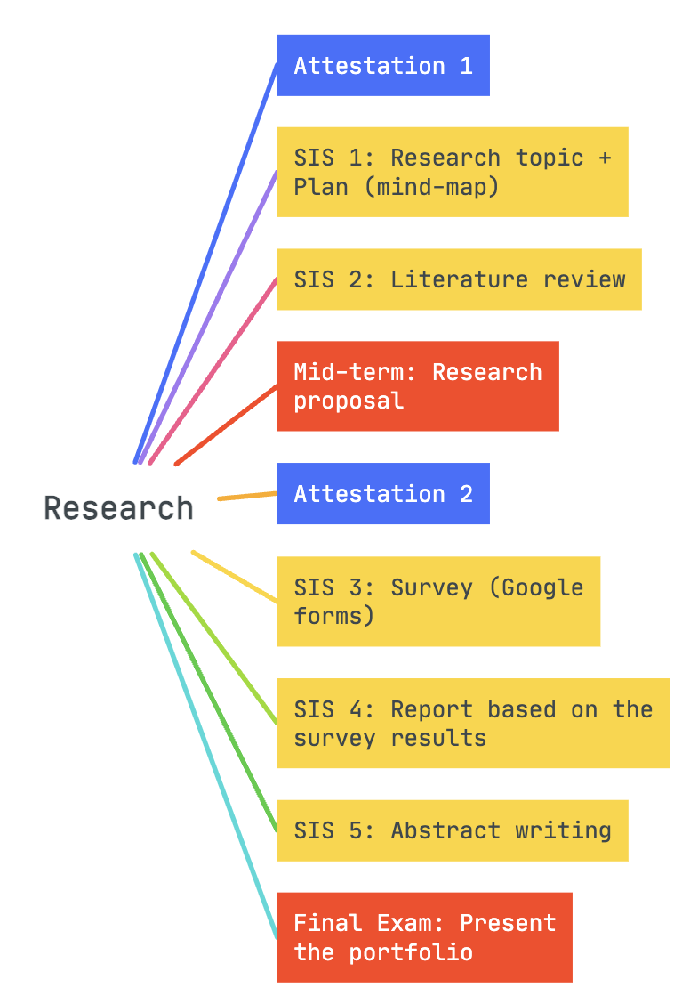

**SIS 1 MIND MAP GUIDELINES**

1. Click [here](https://www.mindmeister.com/) and register in MindMeister (you may use your gmail account) or use another innovative platform to create a mind map
2. Place the main topic at the centre of the map
3. Three issues related to the topic (one issue, one student)
4. Solutions (two solutions for one problem)

**Evaluation rubrics**

|  |  |  |  |  |  |  |
| --- | --- | --- | --- | --- | --- | --- |
| Points number | 10-9 points | 8-7 points | 6-5 points | 4-3 points | 2-1 point | 0 point |
| Organisation | The main idea is supported by details, the categories make sense, and the reader is able to follow and understand what is presented. | The main idea is not fully supported by details, the categories make sense, and the reader is rather able to follow and understand what is presented. | The main idea is slightly supported by details, some categories make sense, and at times the reader is not able to follow and understand what is presented. | The main idea is poorly supported by details, the majority of categories do not make sense, and most of the time the reader is not able to follow what is presented. | There is no recognisable pattern to the ideas. They seem to be a list of thoughts that confuse the audience. | Does not address any part of the task |
| Content | The map has three clear, logical issues and two practical solutions under each related issue. Overall, there are 6 relevant solutions. | The map has three not fully clear and logical issues; and two not fully practical solutions under each related issue. Overall, there are 6 not fully relevant solutions. | The map has three slightly clear, logical issues and two slightly practical solutions under each related issue. Overall, there are 6 slightly relevant solutions. | The map has three or less poorly supported issues and inaccurate practical solutions under each related issue. Overall, there are 6 or less relevant solutions. | The map has three or less irrelevant issues and insufficient practical solutions under each related issue. Overall, there are 6 or less confusing and non-applicable solutions. | Does not address any part of the task |
| Design and creativity | The map has an innovative design, the font is readable. The map is visually appealing and uses colors that work well together. | The map has creative design, the font is readable. The map is somewhat visually appealing and uses colors that work well together. | The map has holistic design, the font is quite readable. The map has slightly limited visuals and uses colors that slightly work together. | The map has slightly inappropriate design and the font is less readable. The map has limited visuals and uses colors that slightly work together. | The map has inappropriate design and the font is non-readable. The map has limited visuals and uses colors that do not work together. | Does not address any part of the task |
| Presentation skills | Clear, articulate and consistent flow of speech. Strong audience engagement by maintaining eye-contact. | Adequate clarity and occasional consistency in a flow of speech. Adequate audience engagement by maintaining eye-contact. | Somewhat adequate clarity and slight inconsistency in a flow of speech. Somewhat adequate audience engagement by maintaining eye-contact. | Slight clarity and consistency in a flow of speech. Slight audience engagement by maintaining eye-contact, sometimes reading from slides. | Inadequate and incoherent flow of speech. No audience engagement, reading from slides. | Does not address any part of the task.  Reading from slides only. |
| Time management  (2 minutes per each student) | Excellent time-management | | Poor time-management. | | |  |

**SIS 2 LITERATURE REVIEW GUIDELINES**

1. Go to Google scholar and find one research article related to your topic.
2. Analyse it and write a summary.

**SUMMARY EVALUATION CHECKLIST**

|  |  |  |
| --- | --- | --- |
|  | Evaluation section | Points  0-1 |
| 1 | There is a reference to the article (the author) in the introductory sentence: e.g. *In the article “TITLE” the author discusses/argues that/presents…* |  |
| 2 | All the main ideas from the given text are included, excluding the student’s own ideas and interpretations. |  |
| 3 | There are no unnecessary details *(statistics, examples) Statistics or examples can be generalized* |  |
| 4 | The intended meaning of the original text is maintained, while avoiding any distortion or misinterpretation. |  |
| 5 | Paraphrasing is effective *(just substituting individual words for synonyms without changing the structure of the original sentence does not count as effective paraphrase)* and the whole summary is presented in the student’s own words |  |
| 6 | The ideas are organised in the logical order |  |
| 7 | The sentences are linked properly with the use of the linking words *(cohesive devices are used effectively to link ideas together and maintain coherence throughout the summary).* |  |
| 8 | There is a range of vocabulary (avoiding repetition of the same words) appropriate for the topic, corresponding to B2 level, at least. There are no more than five lexical mistakes. |  |
| 9 | There is a range of grammar patterns, a mix of sentence types –simple, complex and compound appropriate sentence structures. There are no more than five grammar mistakes and they do not distort the meaning. |  |
| 10 | The summary is between 80-100 words (5-6 sentences) |  |

**SIS 3 GOOGLE FORMS SURVEY GUIDELINES**

1. Go to Google forms and create one questionnaire for the entire group.
2. Each student creates 5-7 research relevant and critical questions, overall, 15 - 20 questions in one google forms, including **sub-topics** per each student’s issue. Questions should be related to research issues and solutions. Thus, the consistent findings and results of the questionnaire should reflect the research aims.
3. Include respondents’ background information in the form of questions related to occupation, age and gender. Include them in the beginning of the questionnaire.

**EVALUATION CHECKLIST**

|  |  |  |
| --- | --- | --- |
|  | Evaluation section | Points  0-2 |
| 1 | Background information |  |
| 2 | Clarity of questions |  |
| 3 | Relevance/Content |  |
| 4 | Critical analysis/interpretation of results |  |
| 5 | Diversity of respondents |  |

**SIS 4**

**SURVEY REPORT PRESENTATION GUIDELINES**

1. Make a PPT presentation in your groups and comment on main findings from the survey results

**EVALUATION RUBRICS**

|  |  |  |  |  |  |  |
| --- | --- | --- | --- | --- | --- | --- |
| Points number | 10-9 points | 8-7 points | 6-5 points | 4-3 points | 2-1 point | 0 point |
| Critical analysis | The main idea is supported by details, the analysis make sense, and the reader is able to follow and understand what is presented. | The main idea is not fully supported by details, the report analysis makes sense, and the reader is rather able to follow and understand what is presented. | The main idea is slightly supported by details, the report analysis is made less critically, and at times the reader is not able to follow and understand what is presented. | The main idea is poorly supported by details, the report analysis does not make critical sense, and most of the time the reader is not able to follow what is presented. | There is no recognisable pattern to the ideas. They seem to be a list of thoughts that confuse the audience. | Does not address any part of the task |
| Presentation skills | Clear, articulate and consistent flow of speech. Strong audience engagement by maintaining eye-contact. | Adequate clarity and occasional consistency in a flow of speech. Adequate audience engagement by maintaining eye-contact. | Somewhat adequate clarity and slight inconsistency in a flow of speech. Somewhat adequate audience engagement by maintaining eye-contact. | Slight clarity and consistency in a flow of speech. Slight audience engagement by maintaining eye-contact, sometimes reading from slides. | Inadequate and incoherent flow of speech. No audience engagement, reading from slides. | Does not address any part of the task.  Reading from slides only. |
| Time management  (2 minutes per each student) | Excellent time-management | | Poor time-management. | | |  |

**SIS 5 FINAL EXAM PART 1 - 10%**

**ABSTRACT GUIDELINES**

**What is an abstract?**

The purpose of an abstract is to summarise the content of the research.

**Key points to remember:**

* An abstract briefly explains the salient aspects of the content.
* Abstracts should be accurate and succinct and readable.
* Abstracts should relate only to the research to be presented.

**Abstract structure:**

* Context
* Research questions
* Aims
* Summary of content
* Conclusions/Significance

**EVALUATION CHECKLIST**

|  |  |  |
| --- | --- | --- |
|  | **Evaluation section** | **Points**  **0-2** |
| 1 | Context |  |
| 2 | Research questions |  |
| 3 | Aims |  |
| 4 | Summary of content |  |
| 5 | Conclusions/Significance |  |